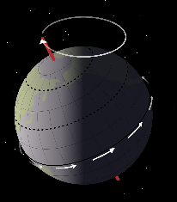
Guided Notes—September 11, 2018
Earth’s Motions
Number the following from smallest to largest (1=smallest, 2= middle, 3=largest)
Milky Way Galaxy Universe Our Solar System
_____ _____ _____
Terrestrial Planets | Jovian Planets

- When Earth is _____________ to the Sun = WINTER
- When Earth is _____________ from the Sun = SUMMER

Precession: __________________________________
________________________________________________________

Nutation: _______________________________________
________________________________________________________
Rotation is the spinning of the Earth from ______
to _________. It takes the Earth ____________ to rotate once! This is what creates ___________ & __________!

Equatorial Bulge: This term states that the Earth is NOT ______________ __________. This is because of the __________________________________________________________________.
Earth’s Seasons = caused by _______________________________________________ (______).
- Equinox: __________ hours of daylight & darkness
- Solstice: __________ day and __________ day.
Draw a diagram of Earth’s seasons below:

My notes: ________________________________________________________________________________________________________________________________________________________________________________________________________________________________________________________________________________________________________________________________________________________________________________________________________________________________________________________________________________________________________________________________________________________________________________________________________________________________________________________________________________________________________________________________________________________________________________________________________________________________________________

