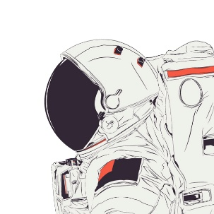
Guided Notes: Introduction to Astronomy Name: _____________________
September 10th
Astronomy is:

- ___________ = everything that exists.

- Models of the Solar System:
_____-centric | Helio-__________
Earth-centered view of the universe | Sun-centered view of the universe
Coined by: ____________ | N. Copernicus (**This is the model we use today!**)

- Galaxies are groups of ___________ stars.
Cosmic size predictions:
My predictions |  | Actual
Size (biggest largest) | Distance from Earth | Size | Distance from Earth
1. | 1. | 1. | 1.
2. | 2. | 2. | 2.
3. | 3. | 3. | 3.
4. | 4. | 4. | 4.
5. | 5. | 5. | 5.
6. | 6. | 6. | 6.
7. | 7. | 7. | 7.

My notes:
_________________________________________________________________________________________________________________________________________________________________________________________________________________________________________________________________________________________________________________________________________________________________________________________________________________________________________
My drawings:

Cosmic Size (large small)

