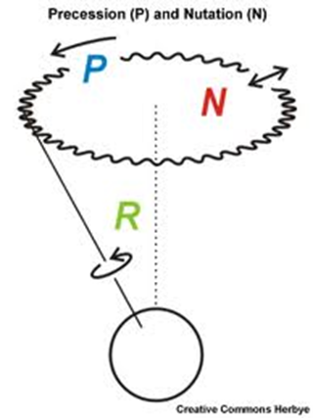
- Nutation:
Definition: A periodic oscillation (nod) of the Earth’s axis that causes the precession of the poles to follow a wavy rather than smooth circular path.

The Activity: Watch the video of the Earth’s precession.

Questions:
1.Explain what nutation is in your own words.
2.What causes nutation to occur based on the text provided on the website.

https://space-geodesy.nasa.gov/multimedia/EarthOrientationAnimations/nutationAndPrecession.html

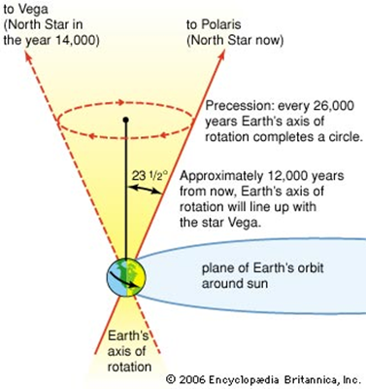
2. Precession:
Definition: the slow, circular, change in direction of the Earth’s axis as it rotates. This 26,000-year cycle causes the “North Star” to change.

The Activity: Watch the video on precession and then, practice viewing precession by spinning the top.
https://www.youtube.com/watch?v=0qHjtp4cdCA

Questions:
1.Is the precession more noticeable when the gyroscope is going faster or slower?
2.Approximately how long does 1 precession of the Earth take?
3. Why do astronomical maps & charts become outdated every 50-100 years

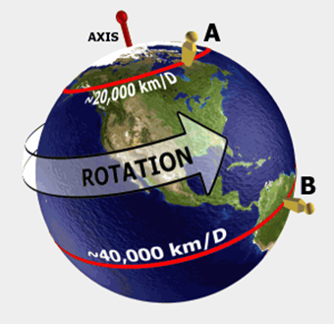
3. Rotation:
Definition: An orbital body (star, planet or moon) turning on its imaginary axis. Rotation causes differences in time, date, light and gives the Earth its shape

The Activity: Watch the two videos on Earth’s rotation and the Moon’s rotation.

https://www.youtube.com/watch?v=pLl8sDZRSYg
https://www.youtube.com/watch?v=exIpL0Uhr_k

Question:
1. How long does it take Earth to make one rotation?
2. In which direction does the Earth rotate?
3. What is caused by Earth’s rotation around the sun?
4. Why do we only see one side of the moon?

4. Revolution:
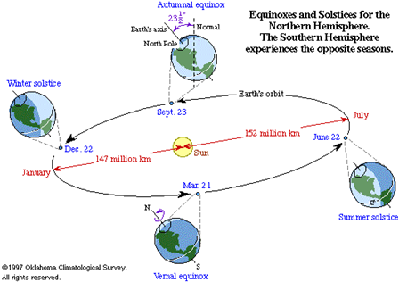

Definition: The path a planet takes as it goes around its star or the path a moon takes as it goes around its planet

The Activity: Choose the preset “Sun & Earth”. Move the sliding bar on the right side to select different planets. Click anywhere in “space” to add more planets. Be patient and watch what happens.

Questions:
1. What affects the speed of a planet’s rotation?
2. How long does it take Earth to make a complete revolution?

Earth’s Motions WebQuest--Answer Sheet

Movement: | Nutation | Precession | Rotation | Revolution
Definition
How long does it take?
Visual/Drawing:

