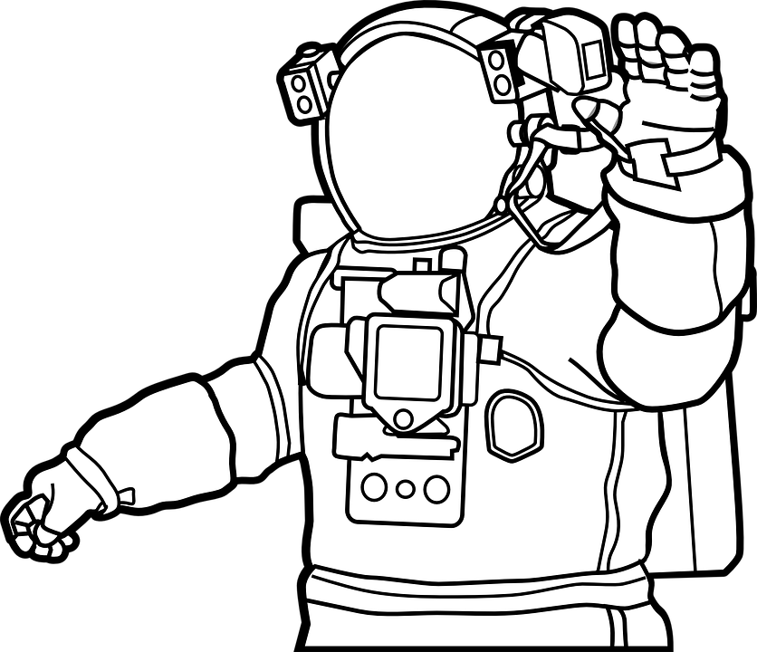
Name: _________________________________

Planet Research
Using your chromebooks, go the following website and research these four planets.

Website: https://spaceplace.nasa.gov/planets/en/

Mercury:
- Mercury is the ___________ in our solar system.
- It is the _____________ to the sun.
- Along with Venus, Earth, and Mars, Mercury is one of the ______ _________. It has a solid surface that is covered with craters. It has a_____ ____________, and it doesn’t have any moons. Mercury likes to keep things simple.
- Mercury takes ___ ______ _____ to make one full rotation.
- How many sunrises are there every 180 Earth days? ________.

Venus:
- Venus is the _______-est planet.
- Its atmosphere is: ______________________________________.
- Venus is unusual because it __________________________ of Earth and most other planets. And its rotation is very slow. It takes about _____ Earth days to spin around just once.
- It takes ____ _____ days for Venus to go all the way around the sun.
- Just like Mercury, Venus doesn’t have any ________.

Earth:
- ______ covers 70% of Earth's surface.
- Our atmosphere is made mostly of _________ and has plenty of _________ for us to breathe.
- The atmosphere also protects us from incoming ___________, most of which break up in our atmosphere before they can strike the surface as ____________.
- Right now, there are many __________ orbiting Earth taking _________ and ____________.

Mars:
- Mars is a _______________.
- It is ____ ___ size of Earth.
- Mars is sometimes called the __________. It's red because of ____ ____in the ground.
- Like Earth, Mars has _______, polar ice caps, _________, canyons, and weather. It has a very ____ atmosphere made of carbon dioxide, nitrogen, and _____.
- On some Martian hillsides, there is evidence of _____ _____ _____ in the ground.

What are some similarities between these four planets? List them below!

